MAJOR/MINOR PROJECT REPORT

ON

ReCircuit: An AI-Enabled E-Waste Management and Smart Buyer Matching System

submitted in partial fulfilment of the requirements for the award of degree of

AMITY SCHOOL OF ENGINERING AND TECHNOLOGY



Submitted by: Supervised By:
Aastha Sawant
A253167023001 Dr. Vivek Bhardwaj
Vivek Khandelwal
A253175123034 Associative Professor

AMITY UNIVERSITY PUNJAB, MOHALI, INDIA

CONTENTS

S.No
1 Introduction
- Literature Review
- Methodology
- Tools and Technologies
- Implementation
- Major Findings/Outcomes/Output/Results
- Conclusion and Future Scope
8 References
9 Appendices

1. Introduction

1.1 Overview
With the rapid advancement in technology, the use of electronic devices such as smartphones, laptops, and other digital equipment has increased significantly. While these devices have made everyday life more convenient, they have also led to a sharp rise in electronic waste, commonly known as e-waste. This type of waste is growing at a fast pace due to frequent upgrades, short product lifecycles, and increasing consumer demand.
E-waste contains harmful substances such as lead, mercury, and cadmium, which can cause serious environmental and health problems if not disposed of properly. When electronic items are thrown away without proper handling, these toxic materials can contaminate soil, water, and air. In many cases, informal recycling practices further worsen the situation by exposing people to unsafe conditions.
Despite growing awareness about environmental sustainability, many individuals still face difficulty in finding proper ways to dispose of their electronic waste. There is often a lack of accessible platforms that guide users through the process or connect them with reliable recyclers and buyers. This gap highlights the need for a smarter and more user-friendly solution.

1.2 Problem Statement
The current methods of e-waste disposal are often unorganized and inefficient. Users usually do not have direct access to verified buyers or recycling services, which makes the process confusing and time-consuming. As a result, many people either store unused electronic items at home or dispose of them improperly.
Another major challenge is that users are generally unaware of how to identify and categorize their e-waste. Without proper classification, it becomes difficult to determine the value or recycling method of the item. This lack of knowledge leads to missed opportunities for reuse and recycling.
Moreover, the absence of a centralized system creates a disconnect between users and recyclers. This not only reduces efficiency but also contributes to environmental pollution. Therefore, there is a clear need for a system that simplifies the process and makes e-waste management more accessible and effective.

1.3 Objective
The main objective of this project is to develop an intelligent and user-friendly system that simplifies the process of e-waste disposal. The proposed system uses image detection techniques to automatically identify different types of electronic waste based on images uploaded by users.
After identifying the category of e-waste, the system applies a smart matching mechanism to connect users with suitable buyers or recyclers. This reduces manual effort and provides users with relevant and reliable options for disposal.
In addition, the project aims to promote environmentally responsible practices by encouraging proper recycling and reuse of electronic components. By combining artificial intelligence with an efficient matching system, the solution seeks to make e-waste management easier, more efficient, and more sustainable.

7. Literature Review
The issue of electronic waste management has gained significant attention in recent years due to its environmental and health impacts. Several studies highlight that e-waste contains hazardous materials such as lead, mercury, and cadmium, which can cause serious damage if not disposed of properly [4][5]. These findings emphasize the need for structured and efficient systems for handling electronic waste.
Research in the field of artificial intelligence has shown that machine learning techniques, especially image classification methods, can be effectively used for identifying objects from images. Convolutional Neural Networks (CNNs) have been widely used for such tasks due to their ability to extract features and recognize patterns in visual data [1]. Frameworks like TensorFlow and Keras provide tools that simplify the development and training of such models [2][3].
Some existing systems focus on general waste classification, where waste is categorized into types such as plastic, metal, and organic materials. While these systems improve waste segregation, they are not specifically designed for electronic waste, which requires more detailed classification and handling.
In addition, a few digital platforms provide services for locating recycling centers or scheduling pickups. However, these platforms usually rely on manual input from users and do not include automated classification or intelligent matching features. This limits their effectiveness and usability.
Based on the reviewed literature, it is clear that there is a gap in combining AI-based image classification with a smart matching system specifically for e-waste management. This project aims to bridge that gap by integrating both technologies into a single platform, making the process more efficient and user-friendly.

3. Methodology
The methodology of this project is designed to provide a clear and systematic approach for managing e-waste using artificial intelligence and a smart matching system. The overall process focuses on simplifying user interaction while ensuring accurate classification and efficient recommendations.
The working of the system begins when a user uploads an image of an electronic waste item through the platform. This image acts as the primary input for the system. Before classification, the image is preprocessed to improve quality and ensure consistency. Basic preprocessing steps such as resizing, normalization, and noise reduction are applied so that the model can analyze the image more effectively.
After preprocessing, the image is passed to a trained classification model. A Convolutional Neural Network (CNN) is used for this purpose, as it is well-suited for image recognition tasks. The model analyzes the visual features of the image and classifies the e-waste into categories such as mobile devices, circuit boards, or other electronic components.
Once the category is identified, the system moves to the next stage, which is the smart matching process. In this stage, the classified result is used to find suitable buyers or recyclers from the database. The matching is based on factors such as the type of e-waste and predefined criteria stored in the system. This ensures that users receive relevant and useful recommendations.
The final step involves presenting the results to the user. The system displays the identified category along with a list of potential buyers or recyclers. This allows the user to choose the most suitable option for disposing of their e-waste.
The overall workflow of the system can be summarized as:
Image Upload → Preprocessing → Classification → Matching → Recommendation
This methodology ensures that the entire process is automated, user-friendly, and efficient. By combining image classification with a smart recommendation system, the project provides a practical solution for improving e-waste management.
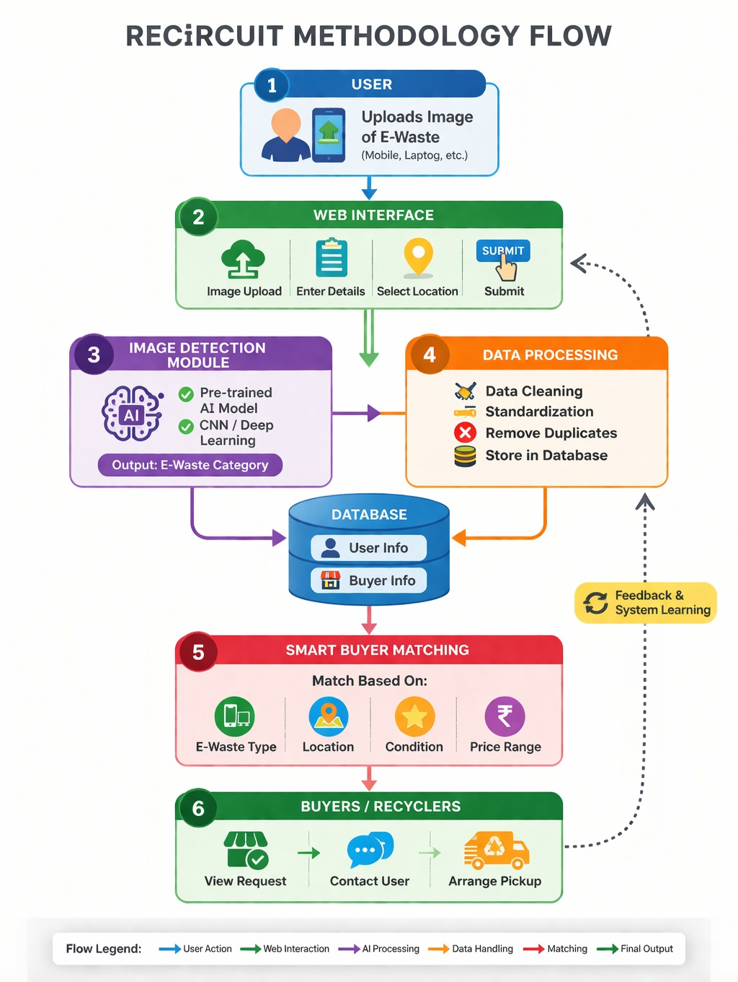
Fig.1 Methodology

4. Tools and Technologies
This project uses a combination of modern web technologies and artificial intelligence tools to develop an efficient and user-friendly system for e-waste management. The selected tools ensure smooth integration between different components of the system.
- Frontend(React.js):
React.js is used to design and develop the user interface of the system. It provides a responsive and interactive platform where users can upload images, view classification results, and access recommended buyers or recyclers. The component-based structure of React helps in maintaining clean and organized code.
- Backend(Node.js and Express.js):
The backend of the system is developed using Node.js along with Express.js. It is responsible for handling user requests, managing data flow, and connecting different parts of the system. It also facilitates communication between the frontend, database, and AI model.
- Artificial Intelligence (TensorFlow and Keras):
TensorFlow and Keras are used for building and training the image classification model. These frameworks provide powerful tools for implementing Convolutional Neural Networks (CNNs), which are used to identify different types of e-waste from images.
- Database (MongoDB):
MongoDB is used to store user data, e-waste categories, and information related to buyers or recyclers. Its flexible structure makes it suitable for handling dynamic data and ensures efficient data retrieval.
- Programming Languages (Python and JavaScript):
Python is used mainly for developing and training the AI model, while JavaScript is used for both frontend and backend development. This combination allows smooth integration between machine learning and web technologies.

5. Implementation
The implementation of the project is carried out in multiple stages, focusing on integrating the frontend, backend, and AI model into a single working system. Each component is developed separately and then combined to ensure smooth functionality.
In the initial stage, the user interface is developed using React.js. The interface is designed to be simple and user-friendly, allowing users to easily upload images of their e-waste. The frontend also displays the classification results and the list of recommended buyers or recyclers in a clear manner.
In the next stage, the backend is developed using Node.js and Express.js. The backend is responsible for handling user requests, processing image data, and managing communication between the frontend, database, and AI model. APIs are created to ensure smooth data transfer and proper system interaction.
The core part of the implementation involves the development of the AI model. A dataset of e-waste images is collected and preprocessed to improve quality and consistency. The images are resized and normalized before being used for training. A Convolutional Neural Network (CNN) model is then trained to classify different types of e-waste such as mobile devices, circuit boards,
and other electronic components. After training, the model is tested to ensure reasonable accuracy.
Once the model is ready, it is integrated with the backend so that it can process images uploaded by users in real time. When a user uploads an image, the backend sends it to the model, which returns the predicted category.
After classification, the matching system is implemented. Based on the identified category, the backend retrieves relevant buyer or recycler information from the database. A simple rule-based logic is used to match users with appropriate options.
Finally, all components are integrated and tested together. The complete workflow—from image upload to classification and recommendation—is verified to ensure that the system works smoothly and efficiently. Minor issues encountered during integration are resolved to improve performance and usability.

6. Major Findings / Outcomes / Results
During the development and testing of the project, several important observations and outcomes were noted.
The system was able to classify different types of e-waste using the trained model with reasonable accuracy. While the model is not perfect, it performs well for common categories such as mobile devices and electronic components. This shows that image-based classification can be effectively applied in this domain.
It was also observed that the overall workflow of the system is simple and easy to use. Users can upload images without any technical difficulty and receive results quickly. This makes the platform accessible even for individuals who do not have prior knowledge of e-waste management.
The smart matching feature successfully provides relevant suggestions based on the identified category. Although the matching logic is basic, it is effective in connecting users with suitable buyers or recyclers. This demonstrates the practical usefulness of integrating a recommendation mechanism into the system.
Another important outcome is that the integration of AI with a web-based platform improves efficiency by reducing manual effort. Tasks such as identifying the type of e-waste and finding appropriate disposal options are automated, which saves time and simplifies the process.
However, during testing, it was noticed that the accuracy of the model depends on the quality and size of the dataset. Limited data can affect performance, especially for less common categories. This highlights the need for further improvement in training data for better results.
Overall, the project demonstrates that combining image classification with a smart matching system can provide a practical and efficient solution for e-waste management. The system shows potential for real-world application with further enhancements.

7. Conclusion and Future Scope
The project “ReCircuit: An AI-Enabled E-Waste Management and Smart Buyer Matching System” demonstrates how technology can be used to address real-world environmental challenges. The system provides a simple and efficient way for users to identify their electronic waste and connect with suitable buyers or recyclers.
By integrating image classification with a smart matching mechanism, the platform reduces the effort required from users and makes the disposal process more organized. It also helps in promoting awareness about responsible e-waste management and encourages recycling and reuse of electronic components.
During the development of the project, it was observed that combining artificial intelligence with a web-based system can significantly improve efficiency and user experience. Although the current system provides a functional solution, there are still areas where improvements can be made.

Future Scope
- The accuracy of the classification model can be improved by training it on a larger and more diverse dataset.
- Location-based matching can be added to provide users with nearby buyers or recyclers.
- A mobile application can be developed to make the system more accessible and user-friendly.
- Additional features such as price estimation and user ratings can be included to enhance the overall experience.
- Integration with authorized recycling organizations or government platforms can make the system more reliable and impactful.
Overall, the project has the potential to be developed into a full-scale real-world solution that contributes to better e-waste management and environmental sustainability.

8. References
- Goodfellow, I., Bengio, Y., & Courville, A. (2016). Deep Learning. MIT Press.
- TensorFlow Documentation. Available at: https://www.tensorflow.org
- Keras Documentation. Available at: https://keras.io
- World Health Organization (WHO). “E-waste and its impact on health.”
- OECD. “Global E-Waste Monitoring Report.”
- Relevant research papers on image classification and Convolutional Neural Networks (CNN), available on IEEE Xplore.
- Articles and resources on e-waste management and recycling practices.

9. Appendices

Appendix A: System Workflow
The system follows a step-by-step process to manage e-waste efficiently:
- The user uploads an image of the electronic waste item through the platform.
- The uploaded image is preprocessed to ensure better quality and consistency.
- The AI model analyzes the image and classifies it into a specific category.
- Based on the identified category, the system searches the database for relevant buyers or recyclers.
- A list of suitable options is displayed to the user for selection.
This workflow ensures that the entire process is simple, automated, and easy to follow.

Appendix B: Sample Input and Output
This section demonstrates how the system works with a basic example:
- Input: Image of an old mobile phone uploaded by the user
- Processed Output: Classified as “Mobile Device”
- Result: List of buyers or recyclers interested in mobile devices
This example shows how the system converts a simple image into meaningful recommendations.

Appendix C: System Components Overview
The system is divided into three main components:
- Frontend: Handles user interaction, image upload, and display of results
- Backend: Manages requests, processes data, and connects different modules
- AI Model: Performs image classification and identifies the type of e-waste
These components work together to ensure smooth functioning of the system.

Appendix D: Future Enhancements (Optional Features)
Some additional features that can be added in the future include:
- Real-time price estimation for different types of e-waste
- User rating and feedback system for buyers or recyclers
- Location-based recommendations for better accessibility
- Integration with government-approved recycling platforms

1

